Assignment 1:

Homography & Panorama

Part A: Homography computation

1. A system of equations of the form $A\underline{x}=\underline{b}$, for projective transformation:

Since we have matching points in 2 images, and we want to find the projective transformation between the two images- we want to find the Homography matrix corresponding for both images.

As we learned in class:

$$\left[\begin{matrix}x^{'} \\ y^{'} \\ z^{'}\end{matrix}\right]=\left[\begin{matrix}a_{1} & a_{2} & a_{3} \\ b_{1} & b_{2} & b_{3} \\ c_{1} & c_{2} & c_{3}\end{matrix}\right]\left[\begin{matrix}x \\ y \\ 1\end{matrix}\right]$$

Therefore we get two linear equations per pair of patching feature points:

$$x^{'}=\frac{a_{1}x+ a_{2}y+ a_{3}}{c_{1}x+ c_{2}y+ c_{3}}$$

$$y^{'}=\frac{b_{1}x+ b_{2}y+ b_{3}}{c_{1}x+ c_{2}y+ c_{3}}$$

We have system of linear equations, $A\underline{x}=\underline{b}$, Where $\underline{x}$ is a vector of unknowns

$$\underline{x}={[a,b,c,d,e,f,g,h,i]}^{T}$$

We need at least 8 equations, because $\underline{x}$ is up-to scale, but the more the better.

With more than 8 equations, the system is over constrained, thus solving using least squares:

$$min{\left\|A\underline{x}-\underline{b}\right\|}^{2}$$

For each pair of matching points, we get 2 equations.

For n pairs of matching points, we will receive the following system:

$${\left[\begin{aligned}\begin{matrix}x_{1} & y_{1} & 1 \\ 0 & 0 & 0\end{matrix} \begin{matrix}0 & 0 & 0 \\ x_{1} & y_{1} & 1\end{matrix} \begin{matrix}-x_{1}^{'}x_{1} & -x_{1}^{'}y_{1} & -x_{1}^{'} \\ -y_{1}^{'}x_{1} & -y_{1}^{'}y_{1} & -y_{1}^{'}\end{matrix} \\ ⋮ \\ \begin{matrix}x_{n} & y_{n} & 1 \\ 0 & 0 & 0\end{matrix} \begin{matrix}0 & 0 & 0 \\ x_{n} & y_{n} & 1\end{matrix} \begin{matrix}-x_{n}^{'}x_{n} & -x_{n}^{'}y_{n} & -x_{n}^{'} \\ -y_{n}^{'}x_{n} & -y_{n}^{'}y_{n} & -y_{n}^{'}\end{matrix}\end{aligned}\right]}_{2nx9}{\left[\begin{aligned}\begin{matrix}h_{00} \\ h_{01} \\ h_{02}\end{matrix} \\ \begin{matrix}h_{10} \\ h_{11} \\ h_{12}\end{matrix} \\ \begin{matrix}h_{20} \\ h_{21} \\ h_{22}\end{matrix}\end{aligned}\right]}_{9}={\left[\begin{aligned}\begin{matrix}0 \\ 0 \\ 0\end{matrix} \\ \begin{matrix}0 \\ ⋮ \\ 0\end{matrix} \\ 0\end{aligned}\right]}_{2n}$$

Since h is only defined up-to scale, we will solve for unit vector $\hat{h}$.

The solution is $\hat{h}$ = eigenvector of $A^{T}A$ with the smallest eigenvalue.

Once we’ve found $\hat{h}$, we can find the conversion matrix H with re-ordering its shape.

1. Implemented in code
2. Result for matches_perfect.mat:

[[ 1.43457214 0.21044323 -1277.18679001]

[ 0.01342652 1.34706123 -16.04558722]

[ 0.00037928 0.00005565 1. ]]

4. The source image after a projective transformation, using the Forward Mapping transform:

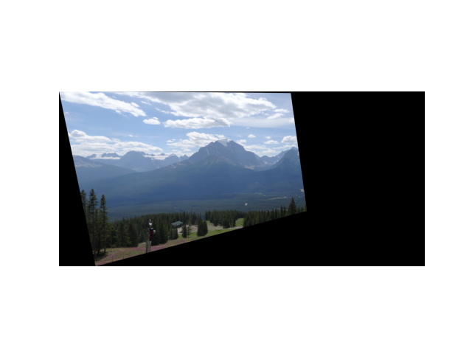

5. The problems with Forward Mapping, is when a pixel from the source image, is mapped to the destination image, it is not guaranteed to fall on exact pixel. We will get a partial-pixel’s value, and we wouldn’t know which pixel matches this value.

Another problem is, that we won’t fill all the pixels in the destination image. There’s a different scale that causes holes between the mapped pixels.

In our image, we used forward mapping with bilinear interpolation to cover the black holes (pixels that had no value after the mapping).

We can see the image is very blurry because the estimation of the interpolation method is not enough.

6. Result for matches.mat:

[[ -0.58601838 -0.13125975 625.47963816]

[ -0.62585177 -0.48527678 817.14319931]

[ -0.00094802 -0.0003852 1. ]]

The source image after a projective transformation, using the Forward Mapping transform:

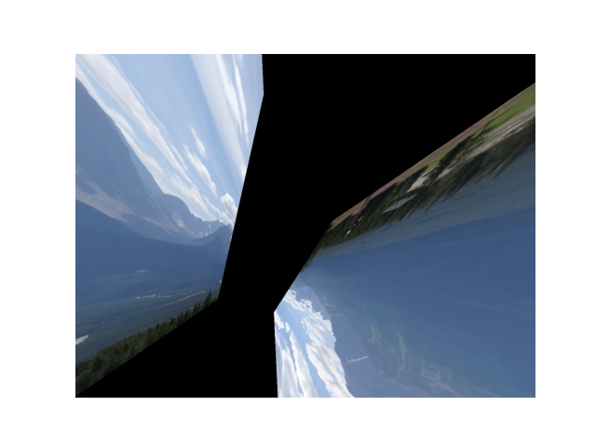

The outcome that has been received is completely different from the matches_perfect result.

The outliers changed the homography matrix and caused a false mapped image.

Part B: Dealing with outliers

7. Implemented in code

8. Implemented in code

9. @paster

10. Result for matches.mat:

[[ 1.47854343 0.25665113 -1337.76283434]

[ 0.00692947 1.44724469 -40.89430266]

[ 0.00036969 0.00015583 1. ]]

The source image after a projective transformation, using the Forward Mapping transform:

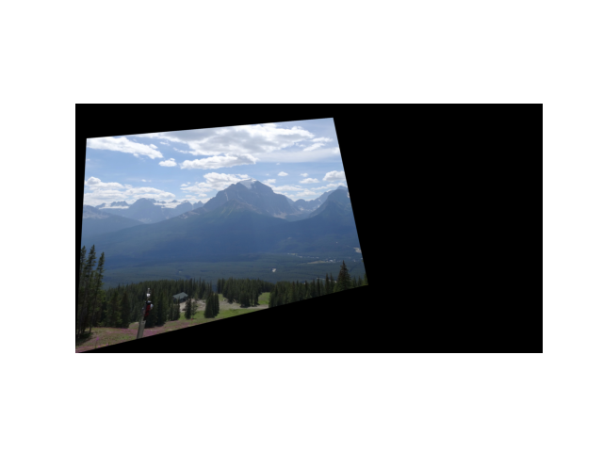

Compare the results @paster

Part C: Panorama creation

11. @paster

12. Implemented in code

13. @paster

14.